For the first extension task, we created a map in Folium that takes in real time data and alerts us to potential severity of flooding at certain postcodes. Red means a dangerous level of severity, orange means high severity, pink means medium severity, and so on.

By inputting postcodes and using the get_lat_long function from our tool file, we attain the latitudes and longitudes of the inputted postcodes. We then put a range of 0.1 degrees around the latitude and longitude values of each postcode. 0.1 degrees comes out to be about 11km. The diameter of the circle around each postcode is therefore about 20km. We chose this value because the average width of a thunderstorm is around 20km.

Afterwards, we found all the stations within this range and calculated the mean rainfall value. We then equated this to the rainfall value of the postcode. To forecast the severity of flooding, we looked at the difference between real time rainfall values and chosen threshold values. For example, for the highest risk areas, we chose a threshold value of 0, and the dangerous alert would come up when the difference comes up to be equal to or above 1mm/15minutes. This decision was based on case studies published by the Met Office; for example, in June 2012, the Southern Part of England experienced severe flooding from rainfall values over 1mm/15minutes. Many other examples can be seen in Met Office reports published on the internet.

The output of the code can be seen here. At one point in time (yesterday 8pm) there was no warning for flooding (light green) in Canterbury area.

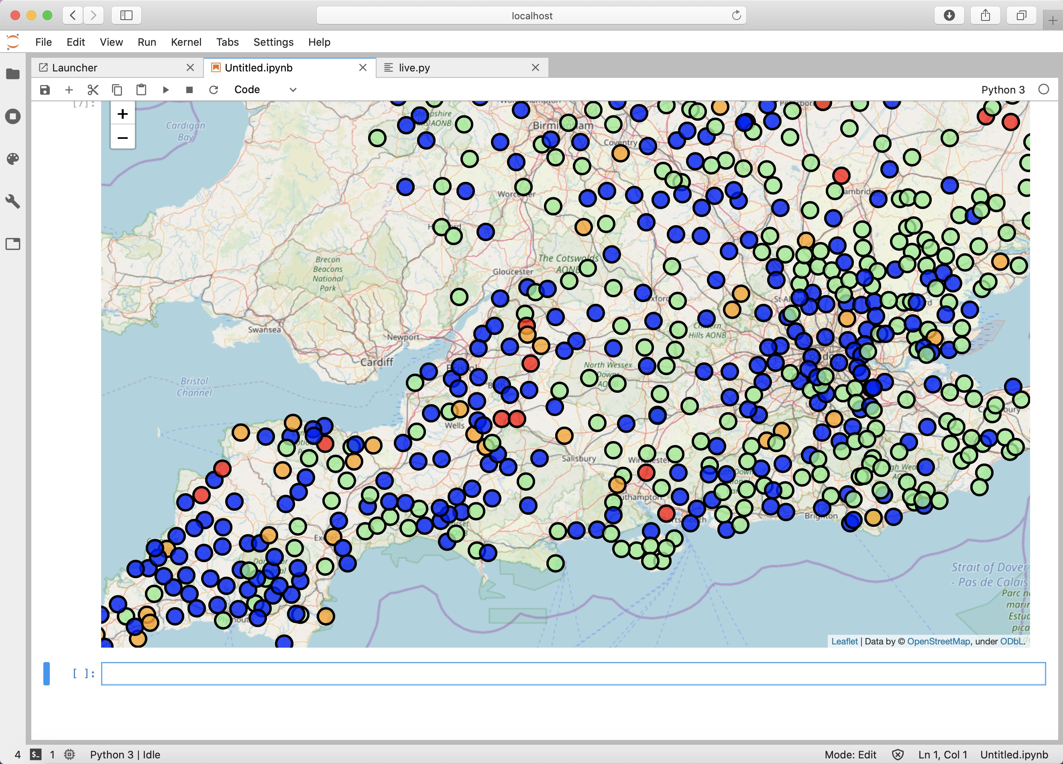

For the second extension task, we wrote the code to categorize the daily rainfall values for station areas in the whole of England. The lowest threshold was the average of the UK daily rainfall as calculated by the Met Office in the 1981-2010 period. The 2nd highest and highest thresholds are the 95th and 99th percentiles of UK daily rainfall as calculated by the Royal Meteorological Office in the 1961-2010 period. Reliable values specific to England could not be found. The figure shows values on the 8th of October, 2019. The red indicates areas that had values higher than the 99th percentile of 13.9mm, whilst the light green indicates areas below the average of 2.34mm. Orange and blue indicates values above the 95th and average values respectively.